**RESEARCH DOCUMENT**

**GOOGLE:**

**PRGI OFFICIAL WEBSITE:**

Link: <https://prgi.gov.in/>

Just the hero page. So, no extra info.

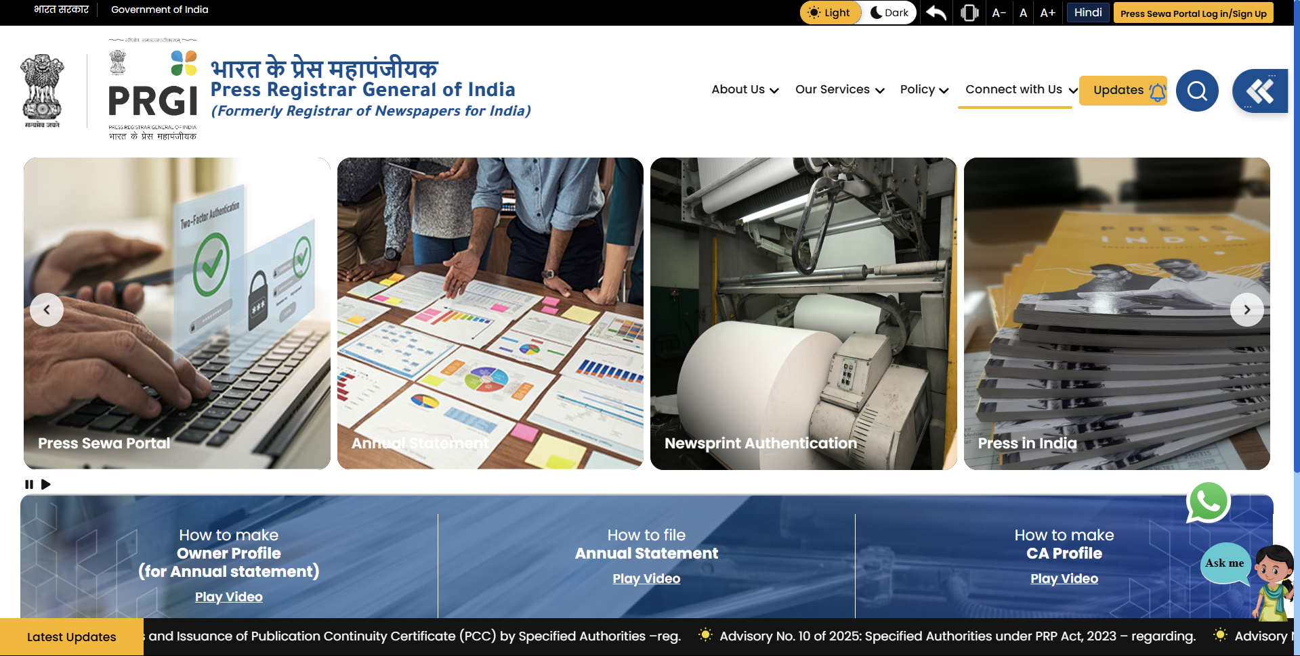

**WIKIPEDIA:**

Link: <https://en.wikipedia.org/wiki/Press_Registrar_General_of_India>

The **Press Registrar General of India** (**PRGI**), formerly the **Registrar of Newspapers for India** (**RNI**), is a [statutory body](https://en.wikipedia.org/wiki/Statutory_body) under the [Ministry of Information and Broadcasting](https://en.wikipedia.org/wiki/Ministry_of_Information_and_Broadcasting_(India)), [Government of India](https://en.wikipedia.org/wiki/Government_of_India), for the registration of newspapers and periodicals. It was established in 1956 by amending the [Press and Registration of Books Act 1867](https://en.wikipedia.org/wiki/List_of_Indian_federal_legislation#1851%E2%80%931875). However, in 2024, the Act was repealed and replaced by the Press & Registration of Periodicals Act, 2023. PRGI is headquartered in New Delhi.

**History**

[[edit](https://en.wikipedia.org/w/index.php?title=Press_Registrar_General_of_India&action=edit&section=1)]

It was established on 1 July 1956, on the recommendation of the First Press Commission in 1953 and by amending the [Press and Registration of Books Act 1867](https://en.wikipedia.org/wiki/List_of_Indian_federal_legislation#1851%E2%80%931875).[[1]](https://en.wikipedia.org/wiki/Press_Registrar_General_of_India#cite_note-nic-1)[[2]](https://en.wikipedia.org/wiki/Press_Registrar_General_of_India#cite_note-RNI-2) RNI regulates and monitors printing and publication of newspapers based on the Press and Registration of Books Act, 1867 and the Registration of Newspapers (Central) Rules, 1956.[[3]](https://en.wikipedia.org/wiki/Press_Registrar_General_of_India#cite_note-3)

The Press and Registration of Books Act contains the duties and functions of the RNI. On account of some more responsibilities entrusted upon RNI during all these years, the office is performing both statutory as well as some non-statutory functions.[[4]](https://en.wikipedia.org/wiki/Press_Registrar_General_of_India#cite_note-mento-4) Online registration system was formally inaugurated in 2004 by the Information and Broadcasting Minister S. Jaipal Reddy.[[5]](https://en.wikipedia.org/wiki/Press_Registrar_General_of_India#cite_note-5) The Press and Registration of Periodicals Act, 2023 was enacted on 28 December 2023 and the name of the office was changed to the present one.

**Duties**

[[edit](https://en.wikipedia.org/w/index.php?title=Press_Registrar_General_of_India&action=edit&section=2)]

Under statutory functions, RNI performs the following duties[[2]](https://en.wikipedia.org/wiki/Press_Registrar_General_of_India#cite_note-RNI-2)

* Compilation and maintenance of a Register of Newspapers containing particulars about all the [newspapers](https://en.wikipedia.org/wiki/Newspaper) published;
* Issue of Certificate of Registration to newspapers [published](https://en.wikipedia.org/wiki/Publishing#Newspaper_publishing) under valid declaration;
* Scrutiny and analysis of [annual statements](https://en.wikipedia.org/wiki/Annual_report) sent by the publishers of newspapers every year under PRB Act containing information on [circulation](https://en.wikipedia.org/wiki/Newspaper_circulation), ownership etc.;
* Informing [district magistrates](https://en.wikipedia.org/wiki/District_collector) about availability of titles, to intending publishers for filing declaration;
* Ensuring that newspapers are published in accordance with the provisions of PRB Act 1867 and the rules made thereunder;
* Verification under Section 19-F of PRB Act, of circulation claims furnished by the publishers in their Annual Statements; and
* Preparation and submission to the Government on or before 31 December each year, a report containing all available information and statistics about the press in India with particular reference to the emerging trends in circulation and in the direction of common ownership units etc.

The following fall under the non-statutory functions:

* Formulation of Newsprint Allocation Policy – Guidelines and issue of Eligibility Certificate to the newspapers to enable them to import [newsprint](https://en.wikipedia.org/wiki/Newsprint) and to procure indigenous newsprint;
* Assessing and certifying the essential need and requirement of newspaper establishments to import [printing and composing machinery](https://en.wikipedia.org/wiki/Printing_press) and allied materials.

**Registration**

[[edit](https://en.wikipedia.org/w/index.php?title=Press_Registrar_General_of_India&action=edit&section=3)]

Registrar maintains the legal procedures for registering a newspaper, which can be summarised as:

1. As a first stage, the applicant applies for title verification of the publication to the jurisdictional District Magistrate. The District Magistrate will get the title verified from RNI.
2. After receiving the title verification letter from RNI, the applicant needs to file a declaration for authentication before District Magistrate.
3. After authentication, the newspaper must be published within 6 weeks if it is published once a week or oftener than that. In case of any other periodicity, the first issue should be published within 3 months from the date of authentication.
4. After the first issue is published, the applicant needs to file an application for [RNI registration](https://www.registrationwala.com/rni-registration), enclosing the following documents
   1. Title verification letter
   2. Authenticated declaration
   3. An affidavit for no foreign tie-up
   4. First issue and latest issue of the publication
   5. Content intimation/ confirmation in the prescribed form
   6. Certificate intimating appointment of the printer

**Registration of Publication**

[[edit](https://en.wikipedia.org/w/index.php?title=Press_Registrar_General_of_India&action=edit&section=4)]

* All publications of India as well as publication imported in India for sales require the mandatory registration with RNI. They are also required to submit their annual report on circulation numbers.[[6]](https://en.wikipedia.org/wiki/Press_Registrar_General_of_India#cite_note-rni1-6)
* As of 31 March 2018, there are 17,573newspapers and 1,00,666 periodicals are registered with RNI.[[7]](https://en.wikipedia.org/wiki/Press_Registrar_General_of_India#cite_note-7)

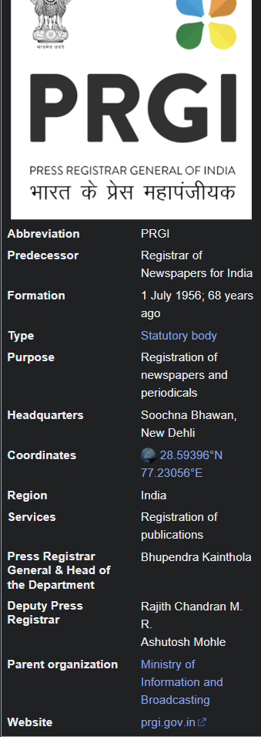

**PRESS INFORMATION BUREAU:**

Link: <https://pib.gov.in/PressReleseDetailm.aspx?PRID=2010874&reg=3&lang=1>

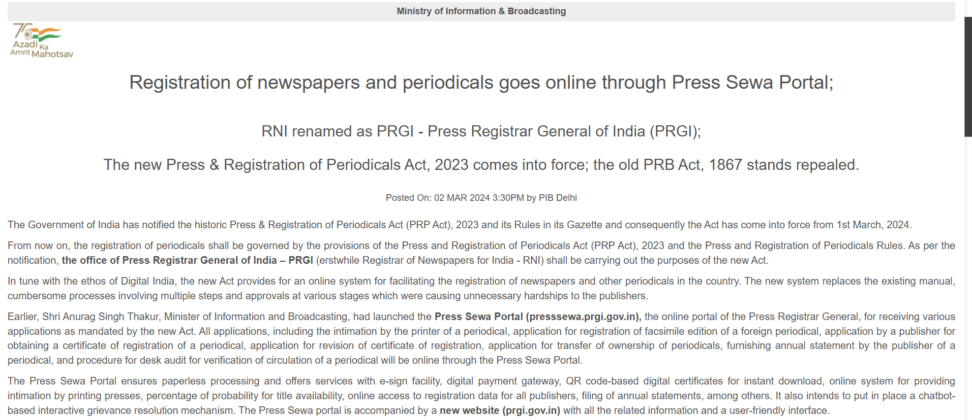

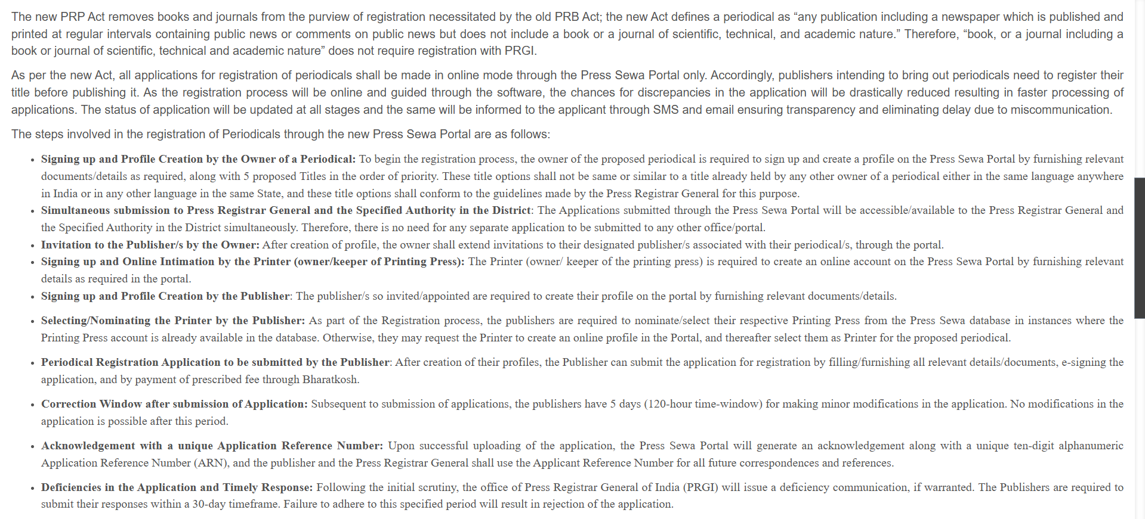

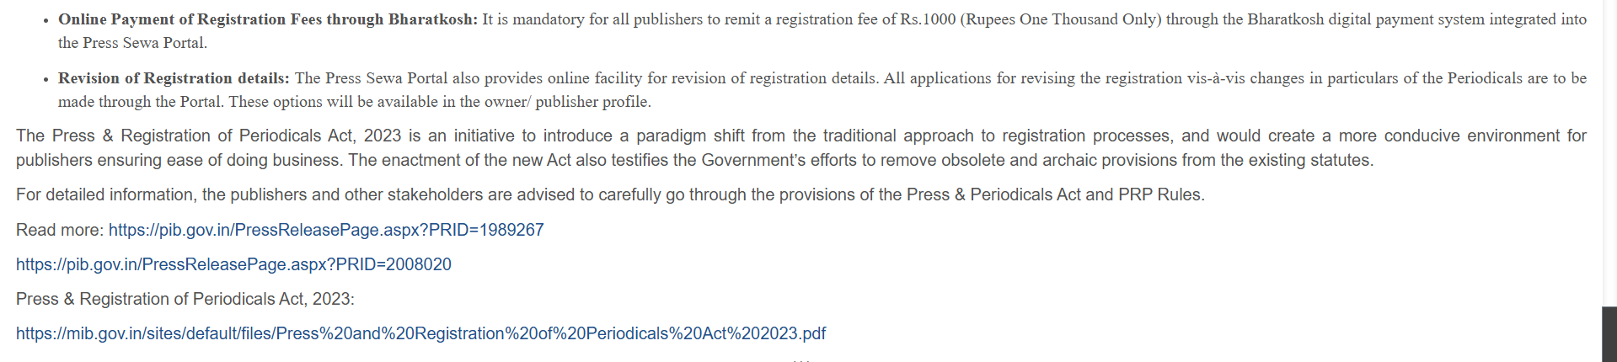

**MINISTRY OF INFORMATION AND BROADCASTING:**

Link: <https://mib.gov.in/ministry/organizations/press-registar-general-india>

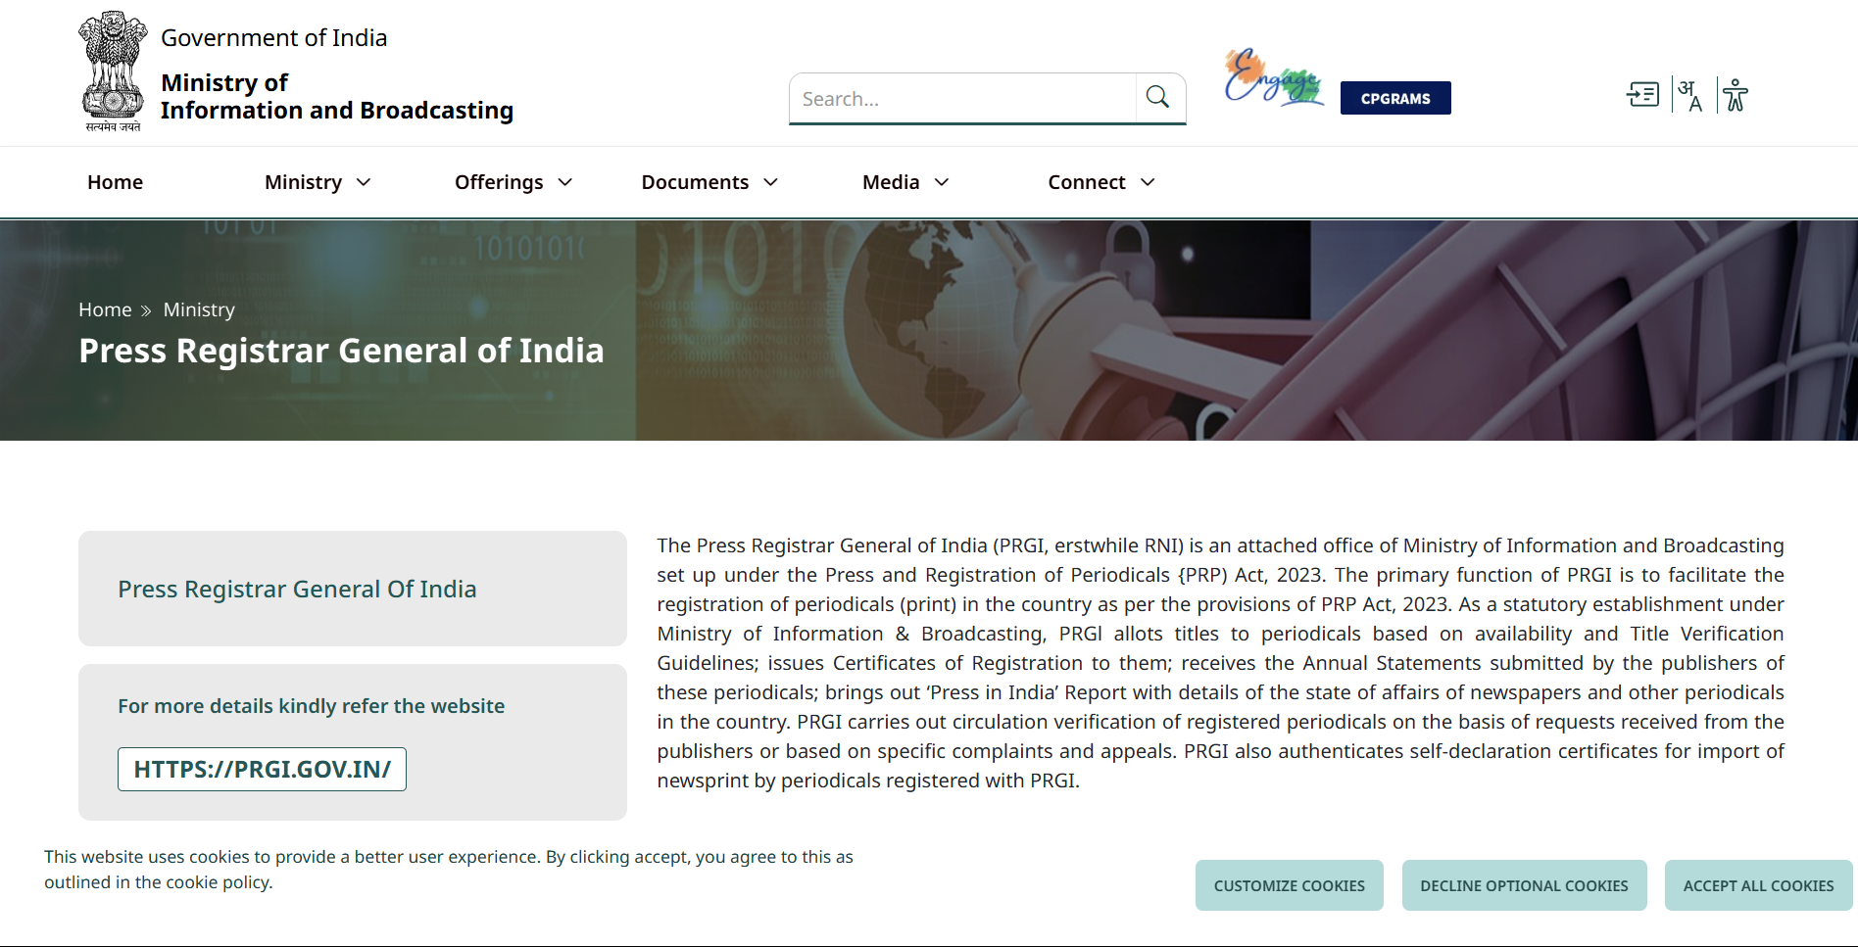

**PRESS SEWA PORTAL – GUIDELINES FOR REGISTRATION:**

Link: <https://prgi.gov.in/policy/guidelines-for-registration>

Complete guide for periodicals registration process.

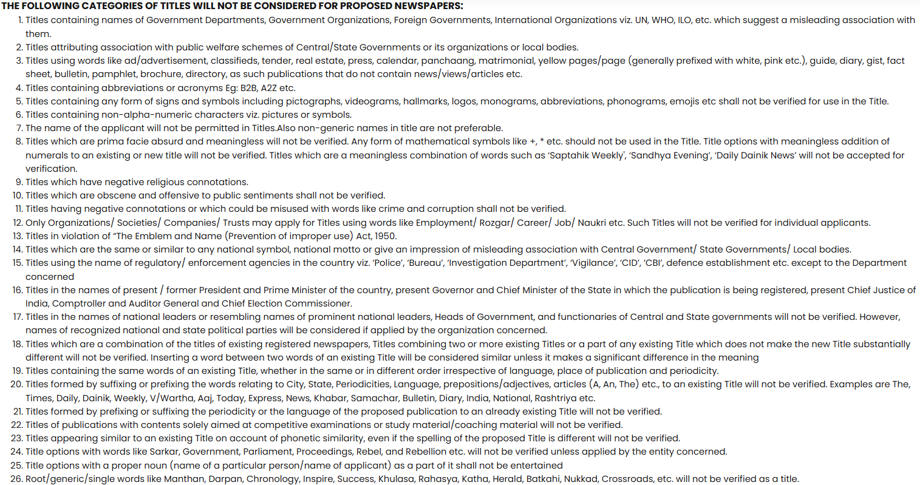

**PRESS SEWA PORTAL – GUIDENLINES FOR ADMISSIBILITY OF TITLES:**

Link: <https://prgi.gov.in/policy/guidelines-admissibility-titles>

Guide for admission acceptability.

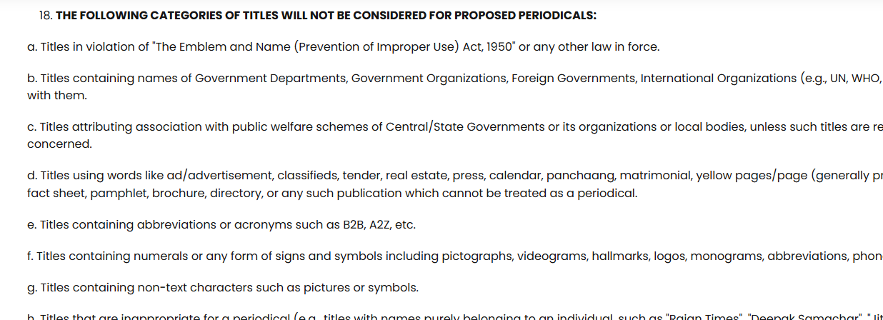

**PRESS SEWA PORTAL – INTRODUCTION TO PRGI:**

Link: <https://prgi.gov.in/sites/default/files/2023-05/Introduction.pdf>

A PDF

**PRESS SEWA PORTAL – NEW PRGI WEBSITE USER MANUAL:**

Link: <https://prgi.gov.in/sites/default/files/2024-06/prgi_user_manual_version_owner-appliccant-publisher.pdf>

A PDF

**TIMES OF INDIA – APRIL 2, 2024:**

Link: <https://timesofindia.indiatimes.com/india/registration-of-newspapers-and-periodicals-goes-online-through-press-sewa-portal/articleshow/108982366.cms>

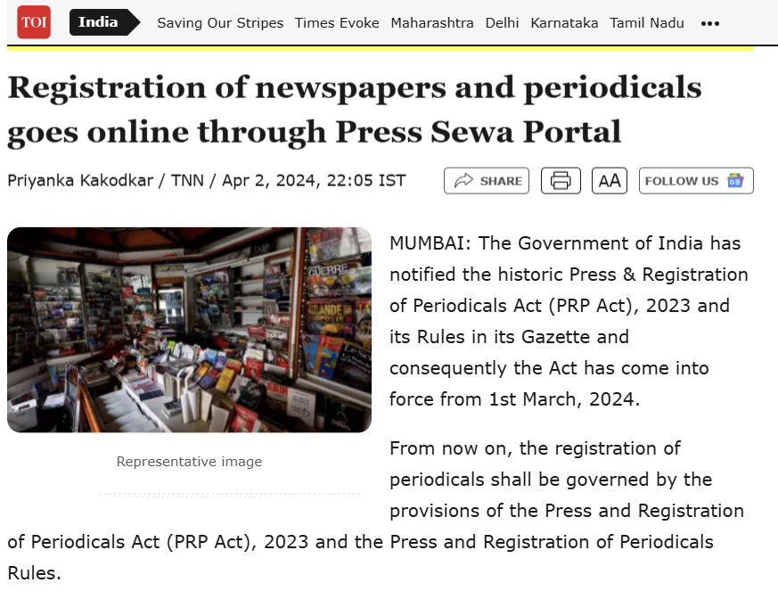

**AI & QUERIES:**

**Does an online automatic verification process for titles in PRGI already available?**

Yes, the Press Registrar General of India (PRGI) does have an online system for verifying titles, which includes a search function to check for existing titles. This system is accessible through the Press Sewa Portal. While it's not a fully automated verification process in the sense of instant approvals, it does provide a mechanism for applicants to check for existing titles before submitting their application.

Here's a more detailed explanation:

Online Title Application:

Applicants can now fill out title application forms online through the Press Sewa Portal.

Title Search Function:

The Press Sewa Portal allows applicants to search for existing titles by entering keywords or phrases to check for similarities.

Verification Process:

While the online system facilitates the search and initial application, the final verification of titles still involves a review by the Press Registrar General of India.

No Automatic Approval:

The search function helps identify potential conflicts, but it doesn't guarantee automatic approval. The final decision on title admissibility remains with the Press Registrar General.

Online Application:

Applicants must submit a printed copy of their online application to the concerned District Magistrate or specified authority for authentication before submitting it to RNI for title verification, according to this RNI guide.

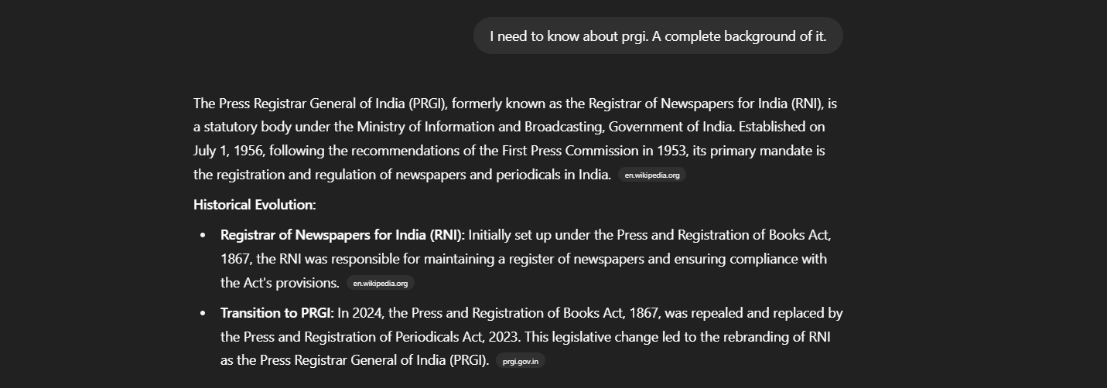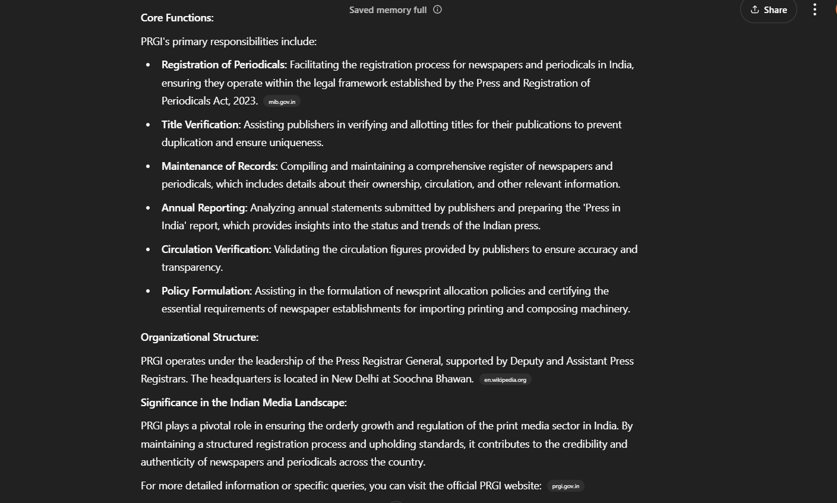

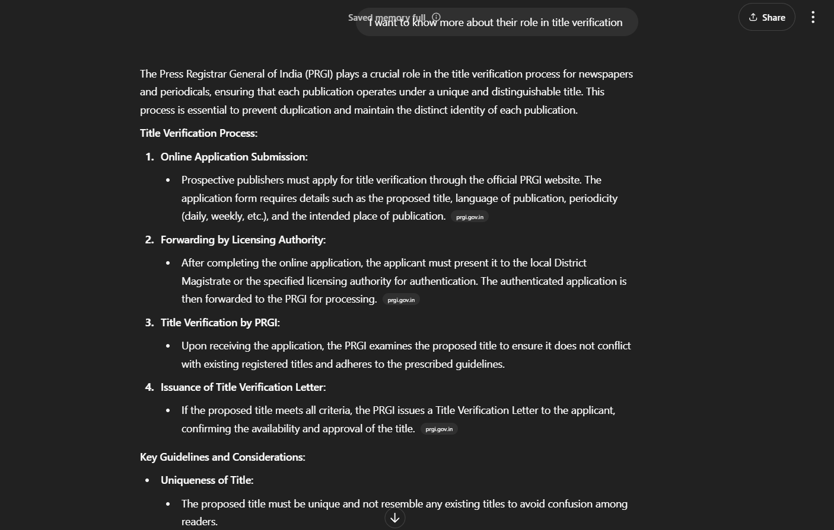 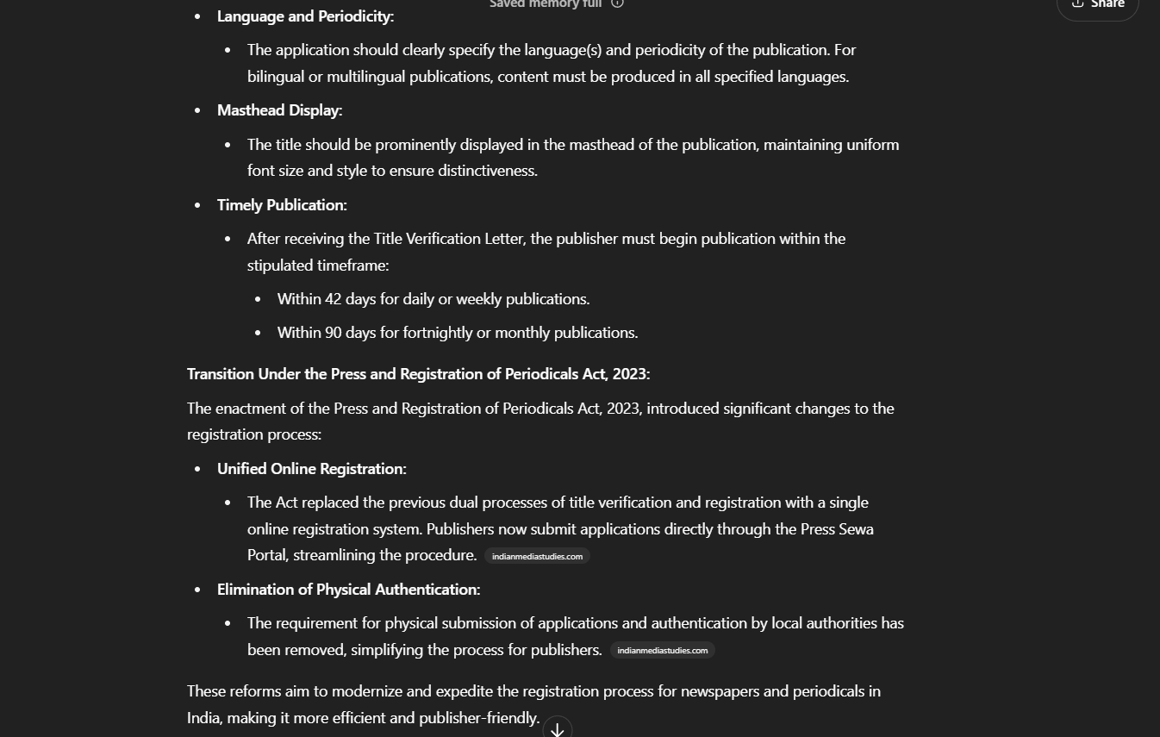

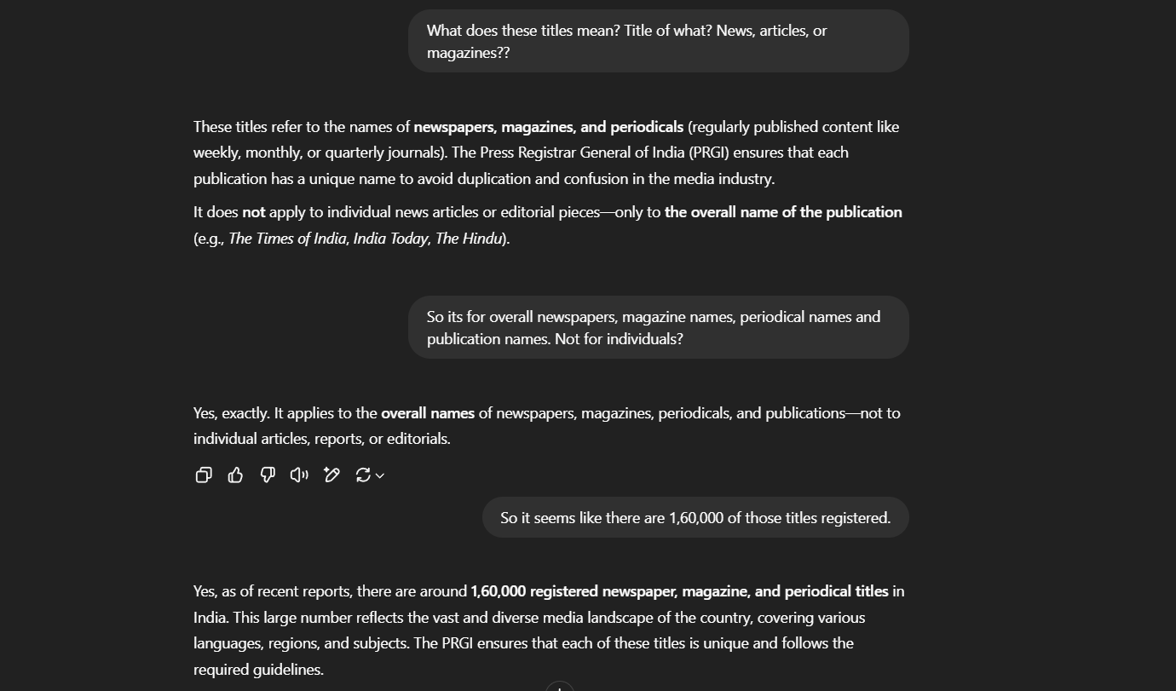

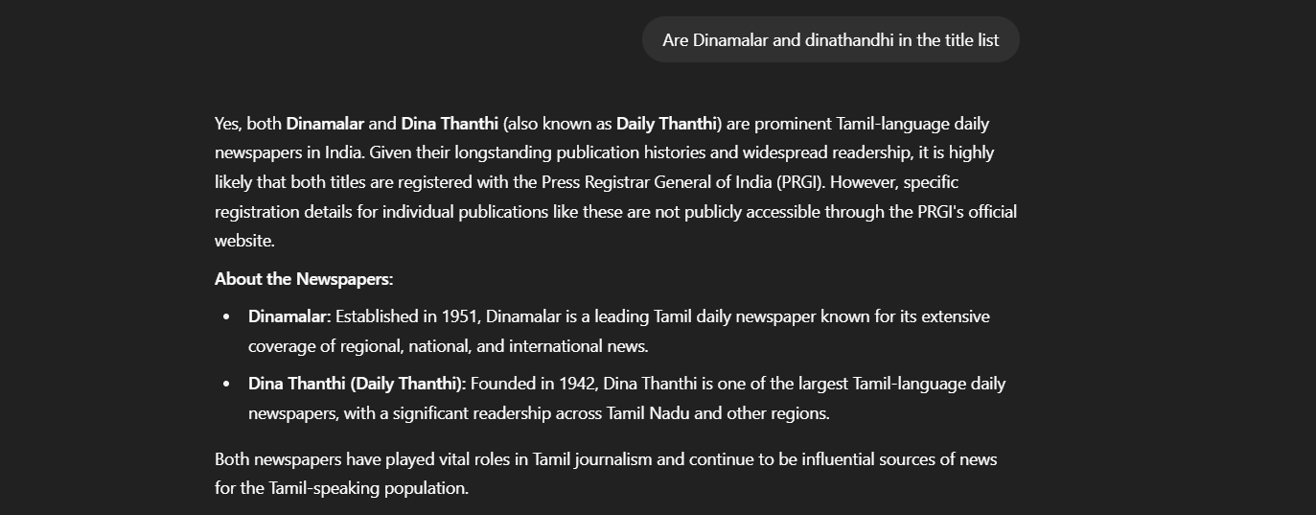

**EVOLUTION OF TITLE VERIFICATION:**

1. **1999: Initial Digitization (Government-Facing):** While the data of registered titles became computerized, this was primarily for internal government use (RNI) to improve their efficiency in checking for title duplication. The application process itself remained largely physical, routed through the District Magistrates. Public access to this digitized data was limited.
2. **2014: Partial Online Application (Hybrid Approach):** The application process saw a significant step towards digitization with the introduction of online form submission. However, this was a hybrid approach. Applicants still had to physically print the online form, get it authenticated by the District Magistrate, and then it was forwarded to the RNI. Communication regarding title verification also involved physical letters, though these could be downloaded online.
3. **2023: Fully Online Interface (Streamlined but Not Fully Automated):** The enactment of the PRP Act, 2023, and the launch of the Press Sewa Portal marked a significant leap towards a fully online interface. Applications are submitted directly online to the PRGI, eliminating the mandatory involvement of the District Magistrate in the initial application. The provision of a searchable list of verified titles offers applicants a reference point.

**Regarding Complete Automation and Acceptance Probability:**

You are correct in observing that despite the significant digitalization, the **core title verification process is still not completely automated.** Here's why and what the current situation is:

* **Manual Verification Remains Crucial:** The PRGI guidelines for title admissibility involve subjective criteria beyond just exact matches. These include assessing if a title is "misleading," "scandalous," "likely to promote disharmony," or too similar in sound or appearance to existing titles, even with slight variations. These nuanced judgments currently require human evaluation and cannot be entirely replaced by algorithms.
* **Complexity of Linguistic Variations:** India's vast linguistic diversity adds another layer of complexity. Automated systems would need sophisticated natural language processing capabilities to accurately assess the similarity of titles across different languages and scripts, considering transliteration and potential for confusion.
* **Legal Interpretation:** The interpretation and application of the guidelines for title admissibility ultimately rest with the Press Registrar General. This involves legal considerations that are not easily codified into a fully automated system.

**Is there any system to provide acceptance probability?**

**Currently, there is no official system provided by the PRGI (or formerly RNI) that offers a probability of acceptance for a proposed title.**

While the availability of the list of verified titles on the Press Sewa Portal is a valuable resource for applicants to gauge potential conflicts, it doesn't provide a predictive probability. The final decision rests on a manual evaluation based on the comprehensive guidelines.

**Why no acceptance probability system exists (likely reasons):**

* **Subjectivity of Criteria:** As mentioned earlier, many of the rejection criteria are subjective and depend on interpretation, making it difficult to assign a numerical probability.
* **Potential for Misinterpretation:** Providing a probability could be misleading if applicants rely solely on that without fully understanding the detailed guidelines.
* **Dynamic Nature of the Database:** The database of registered titles is constantly evolving with new registrations and deregistrations.

**In conclusion, while the title verification process has become significantly more efficient and transparent through online platforms, the core verification itself remains a manual process due to the need for nuanced judgment and the complexities of linguistic diversity and legal interpretation. There is currently no system in place to provide an acceptance probability for proposed titles.**

**END**